External Documentations For Final Game

Mitul Patel

ICS 3U1

Game ISU

6/19/2017

Instructions Manual

When you debug the Game you will approach a menu that has a really cool background and several buttons. The start button will hide the main menu and start the game, It will load a different game screen form. The instructions button will allow you to read the instructions on how to play the game. You then go back on the main menu from the instructions button. There is also an exit button which will stop the applications. There is also a name section that you can register but there is no purpose to using that because it does not have a task. It will only prompt you with a message box that says your name and you can click okay. Finally there is also a Combo Box button that allows you to set the different difficulty of the game. There is an easy medium and hard. You may decide that first. If no difficulty is set, than the game will default to easy mode.

When you click the game button it will take you to the game screen. Here you will find Bowser moving up and down the screen, there are also 3 Goombas on 3 platforms. The task is to use the inbuilt errors that I was not able to fix to get to peach in any way possible. When you reach peach, you will have completed the gam e.

Errors In my code

There is one specific error that I was unable to fix which happens due to the ylimit. As Mario reaches to the top of a Platform, the ylimit will change, however when you walk horizontally off the platform, Mario does not drop to the ground and this is due to the gravity. Also when Mario walks horizontally off the platform, the ylimit does reset to the ylimit of the bottom of the screen, but Mario or the player does not drop to the bottom, However Mario does drop to ylimit if Mario jumps. Nevertheless, if I interest with any Goomba enemy I made it so that the location would change to spawn, however the X value is accurate, but the Y value of the player still remains on top of the platform. Furthermore, the name input in the main menu does not really do anything useful. Lastly, when Mario is on the highest platform, and when he jumps, it will momentarily remain on top of the game screen form for a second and then drop.

Other Things That Work.

Aside from that, I created a decently working game that is not only challenging, but also fun to play. I use various types of variable, along with the use of Arrays and Methods and countless Event Methods that work completely accurate. I also use many other things in the code to get what I wished to desire in my game. I was able to have sounds playing in the background and transfer information from Form 1 to the game screen form. As a result, I was able to set the difficulty levels. Here are several screen shots that indicate what I mean.

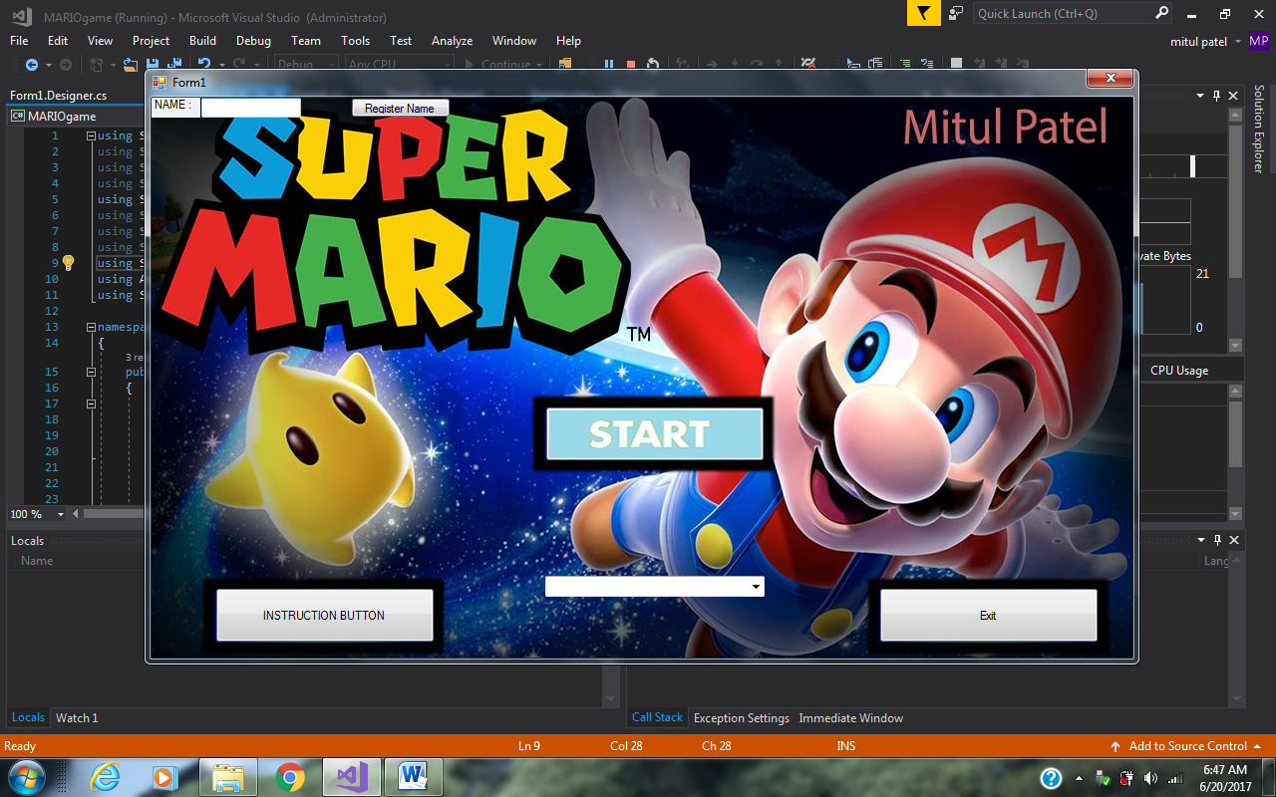This is my Main menu of the Game. Has a start button, an exit button, an Instructions button, a name label, a register name button, a textbox,and a difficulty combo Box button.

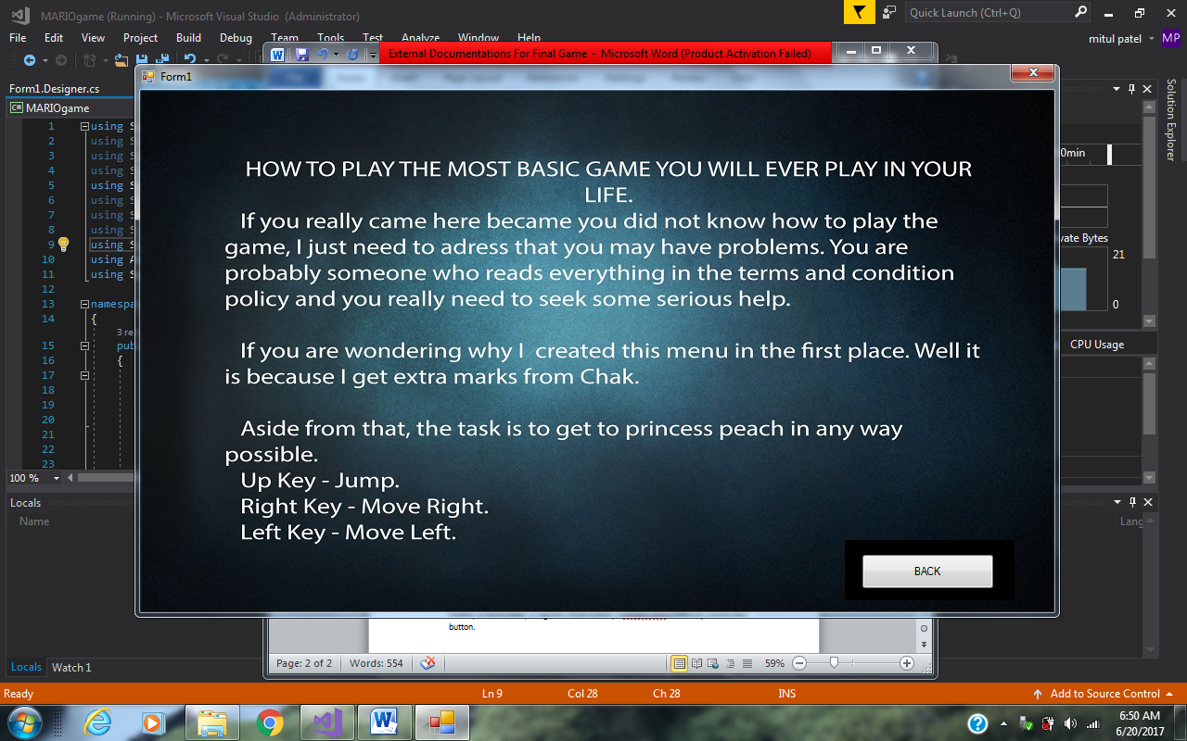

This is my Instruction menu, has a few spelling errors and grammar errors, but it is there. There is also a back button there to go back when desired.

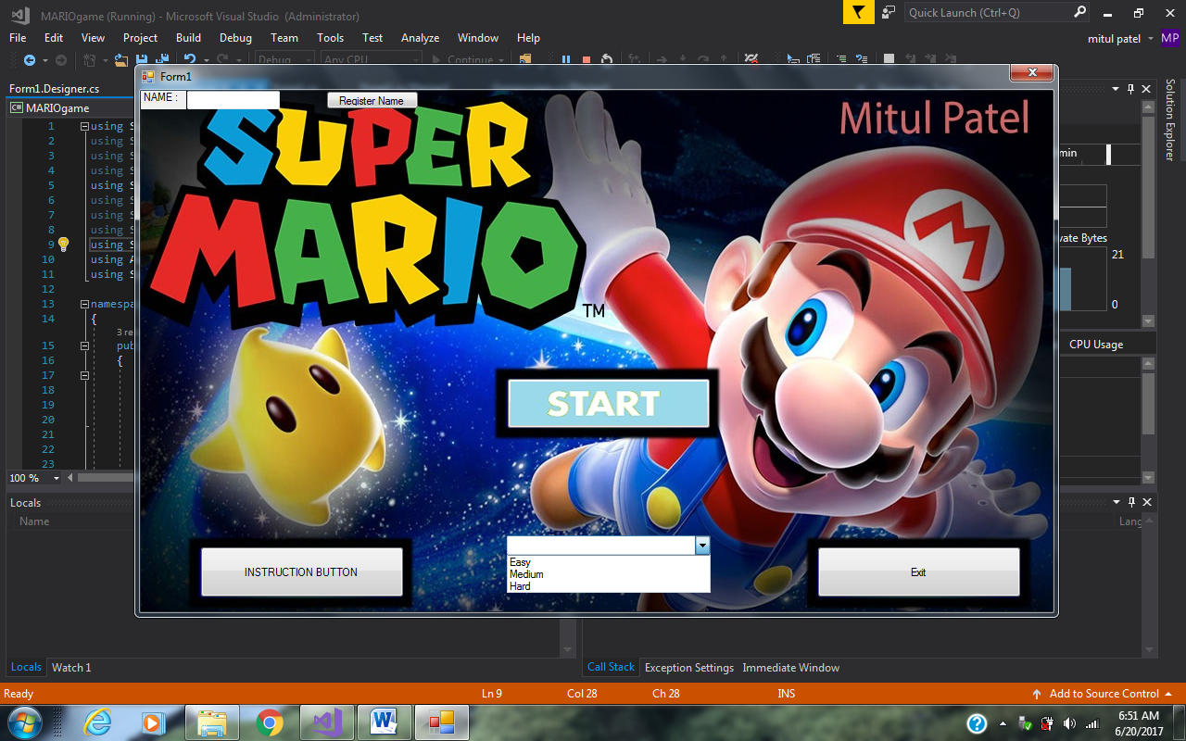AS you can see there is also a Combo Box drop down options to select a difficulty level of the game. Select first then press play or else the game will default to easy.

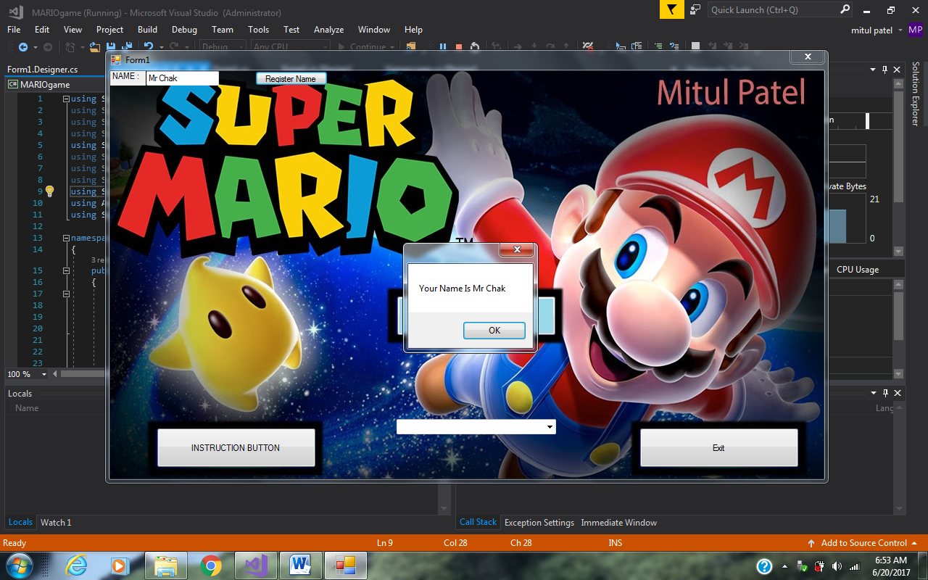Name input that does not do anything but show this message box when register clicks

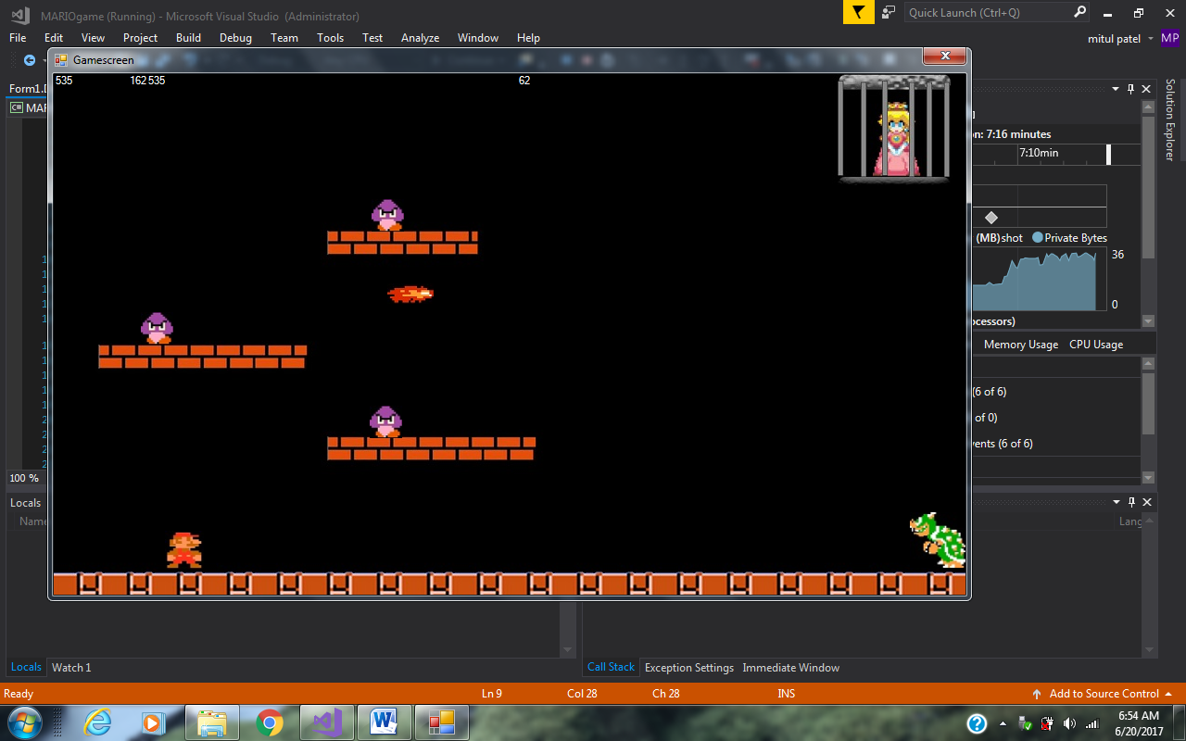

Game screen that you are able to play with bowser Goomba moving, sound and a fire ball.

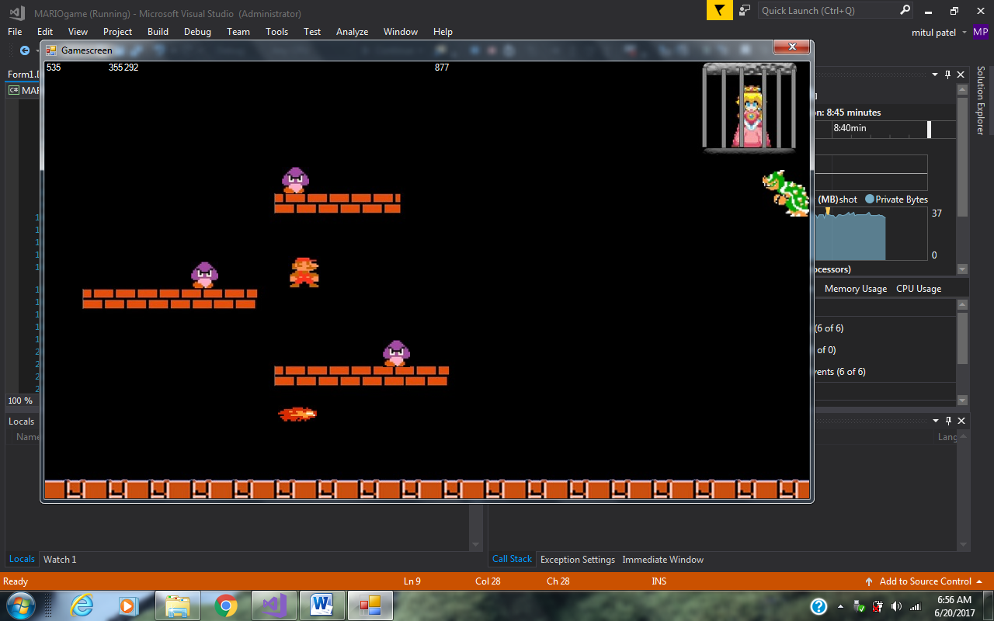The error that occurs when Mario leaves the platform

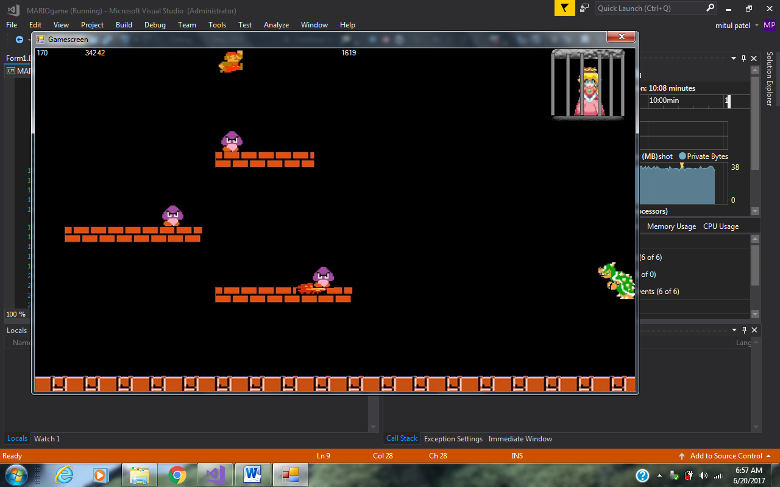

This is place where the delay of an instance occurs when Mario seems to stay in the air.

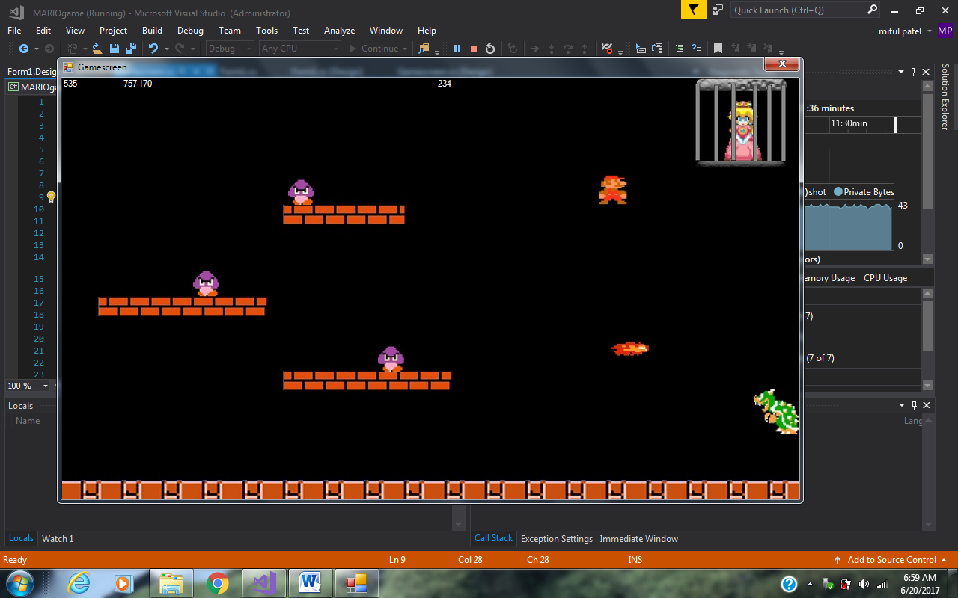

Using the error as an advantage to complete the game.